C Language
________________________________________________________________________

Q. what is c language?
_______________________________________________________________________
C is high level programming language

Q. what is programming language?
_________________________________________________________________________________
Programming means logical thought process of or logical thinking person
called as programming

Q. what is coding?
___________________________________________________________________________
If we convert your logical thinking in to computer instruction called as code.

How to create application by using c language
______________________________________________________________________________
If we want to create application by using c language we have some important steps.

1. Installed Turboc++ as editor
_________________________________________________________________
Q. what is turboc++?
__________________________________________________________________________
turboc++ is editor which provide environment to us to create and execute c program
if we want to download the turboc++ you can visit the following link
https://developerinsider.co/download-turbo-c-for-windows-7-8-8-1-and-windows-10-32-64-bit-full-screen/

2. Create Simple Application
________________________________________________________________
if we want to create application in c language we have some important steps.
a) Add header file in code
______________________________________________________
Q. what is header file?
__________________________________________________________________
header file is collection of functions
Q. what is function?
_____________________________________________________
functions are the some statements which help us to write some logic or execute the some code.
e.g printf(),scanf() etc

if we want to work with c program we need required minimum two header files
stdio.h : stdio.h stands for standard input and output header file
conio.h: console input and output header file
if we want to add header file in code we have to use #include keyword
#include<filename.h>
Example: #include<stdio.h>
#include<conio.h>

b) Write main function and logic in it.
Q. what is main function?
__________________________________________________________________
Main function is heart of c language we cannot run any c program without main function.

Syntax: void main(){
write here your logics
}

Example: we want to print good morning message on program output screen.
if we want to print anything in c language we have printf() function and this function present in stdio.h header file.
Syntax: printf(“message”);
Example: printf(“good morning”);
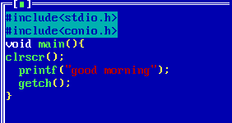
3. Save the application
4. Run the application

Data Types in C Language
_______________________________________________________________
Q. what is data type?
____________________________________________________________________
Data type means to decide what kind of information we are going to us in code called as data type.

There are three types of data type in c language?
__________________________________________________________________________
1. Built In Data Type: those data type already present in c language or provided by c language to us called as user defined data type.
There are three types of built in data type
_______________________________________________________________
a) Integer: Integer data type is used for store the values without decimal point
Example: 100,200 etc
There are four types of integer data type
_________________________________________________________________
i) Integer
How to use in program: int
Memory required: 2byte
Q. why 2 byte required?
________________________________________________
It is not fix it is dependent on compiler suppose we have some 16 bit,some 32 etc
Example:
Suppose TCC compiler required 2 byte of memory for integer
GCC compiler required 4 byte of memory for integer
JIT compiler required 4 byte of memory for integer.

Q. Can we see the memory size of data type?
________________________________________________________________________
yes we can see the memory size of data type and for that we have sizeof() operator.
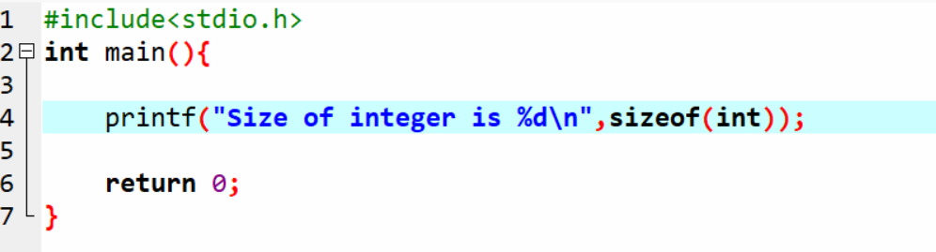

Range: range means value storage capacity of data type.
-32768 to 32767

How it is calculated?
__________________________________________________________
Range is dependent on memory size of data type.
Format specifier: format specifier means how we can represent
data type in printf() and in scanf()
%d
ii) Long Integer
_______________________________________________________
How to use in program: long int
Memory size: 4 byte
Range: -2147483648 to 2147483647
Format specifier: %ld

iii) Unsigned integer: unsigned integer is used for store only positive values.
How to use code: unsigned int
Memory required: 2 byte
Range: 0 to 65535
Format specifier : %u
iv) Short integer:
How to use in program: short int
Memory required: 2 byte
Range: -32768 to 32767
Format Specifier: %i or %d

b) Float: float data type is used for store the floating values.
There are three types of float data type
____________________________________________________________________________
I) float :
How to use in program: float
Memory required: 4 byte
Range: 38 38
-3.14 x 10 to 3.14 x 10
Format Specifier: %f
II) double:
How to use in program: double
Memory Required: 8 byte
Range: 308 308
-1.7 x 10 to 1.7 x 10
Format Specifier: %lf
III) long double
How to use in program: long double
Memory required: 10 byte
Range: 4932 4932
-1.7 x 10 to 1.7 x 10
Format Specifier: %Lf

c) Character: Character Data Type is used for store the alpha numeric values.

There are two types of character data type
i) sign char
How to use in program: char
Memory required: 1 byte
Range: -128 to 127
format specifier:%c
ii) unsigned char
How to use in program: unsigned char
Memory required: 1 byte
Range: 0 to 255

2. Derived Data Type: those data acquire the properties from another data type called as derived data type.
a) Pointer
b) Function
c) Array
3. User Defined Data Type: those data type define by user for its own use called as user defined data type.

a) Structure
b) Union
c) Enum

Operators in C Language: operator is the some symbols which is used for perform some operations.

There are seven types of operator in c language
1. Arithmetic operator: it is used for perform arithmetic operations.
Operator | Meaning
+ | Addition
- | Subtraction
* | Multiplication
/ | Division
% | Reminder or Mod
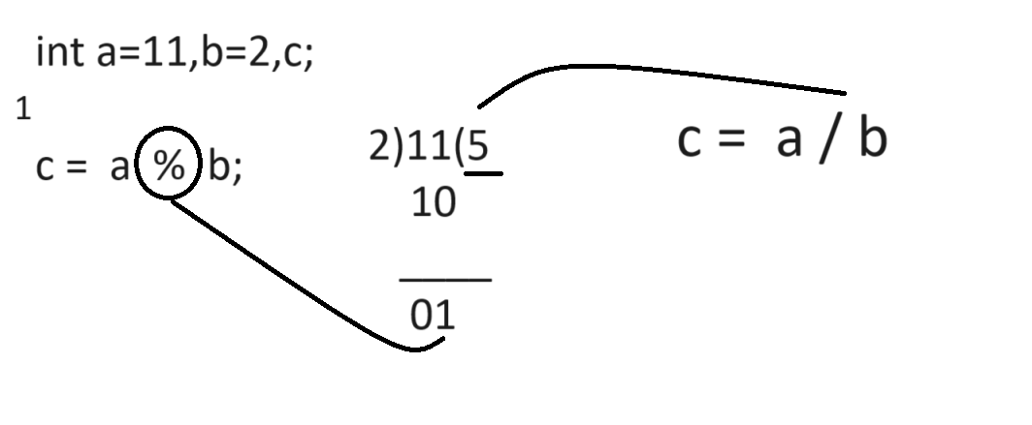

Q. what will be output of given code?
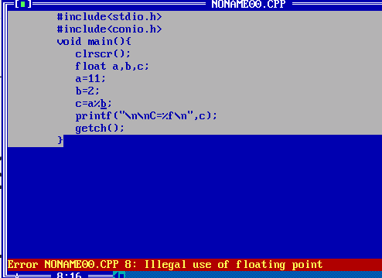
Note: Above code generate compile time error to us illegal use of floating point.
Because we use the reminder operator or mod operator with floats values but in c language there is rule we cannot use reminder or mod operator with floating data type.

How I can calculate reminder of floating values in c language
_____________________________________________________________________
There are two ways to calculate reminder of floating values
A) Using fmod() from math.h header file.
______________________________________________________________
fmod() is function from math.h header file which is used for calculate reminder of floating values.
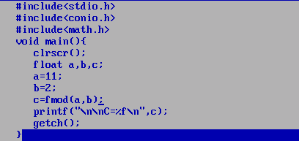
Output: C = 1.00000

B) Using type casting technique
Q. what is type casting?
________________________________________________________________________
Type casting means convert one type of data in to another type for single line of code called as type casting.

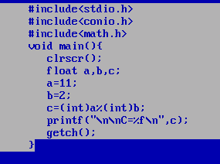

2. Assignment operator : it is used for assign right hand side value to left hand side variable.
Operator | Meaning
= | Assign

3. Relational operator: Relational operator is used for perform comparison if comparison gets success return 1 otherwise return 0. In The case of c language 1 means true and 0 means false.
Operator | Meaning
> | Greater than
< | Less Than
>= | Greater than equal
<= | Less Than Equal
== | Equal
!= | Not Equal
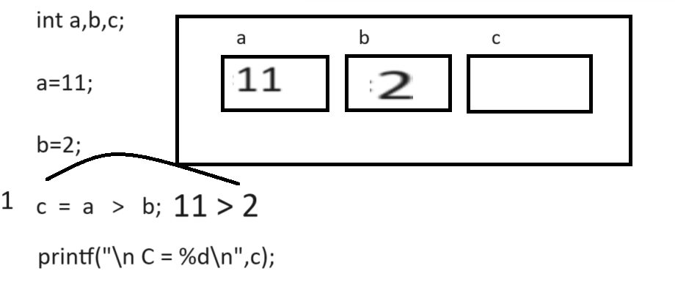
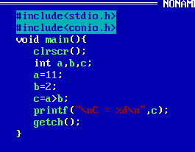

4. Logical Operator: Logical operator is used for combine more than one conditions and checks it or mark it as single condition.

Operator | Meaning
&& | Logical AND if we think about AND operator if all conditions are true then condition is true otherwise condition is false.
|| | Logical OR if we think about Logical OR if any one condition is true then condition is true if all conditions are false then condition false.
! | Logical NOT if true condition then false and if false then true.

Note: Every logical Operator work as Logical Gate Internally and condition consider as input to logical Gate.
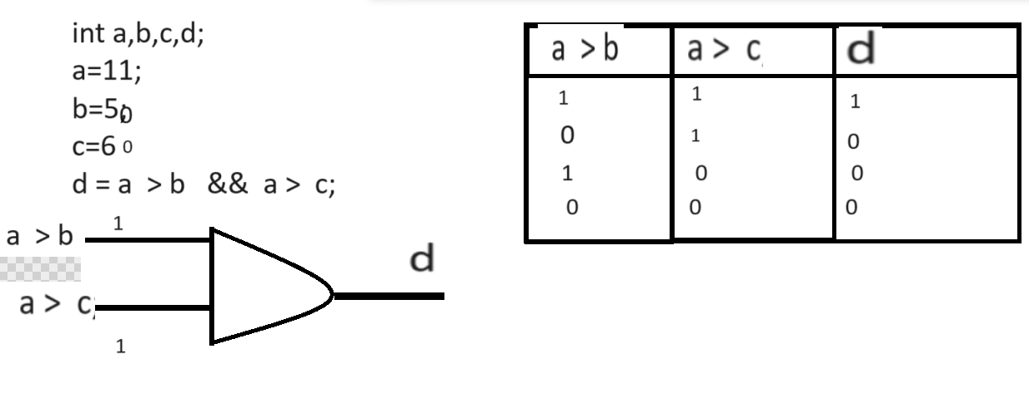

5. Increment or decrement: it is used for increase value by 1 or decrease value by 1
It is short cut of +1 and -1
There are two types of operator
Operator | Meaning
++ | Increase by 1
-- | Decrease by 1

There are two types of increment and decrement operator
_______________________________________________________________________________
Post Increment and Post Decrement: In the case of post operation first we initialize value at left hand side and after that we perform operation on it.
Syntax: variablename op;
int a=10;
int b=a++;

Pre Increment and Pre Decrement: In the case of pre increment operation or pre decrement operation first we perform operation and after that shift value at left hand side.

Syntax: op variablename;
Example: int a=10;
++a;// pre increment

Example of post increment
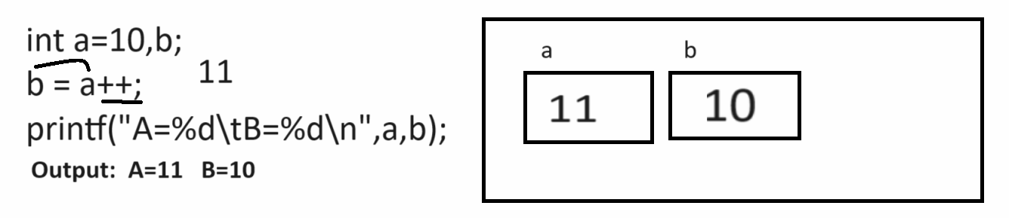
Output
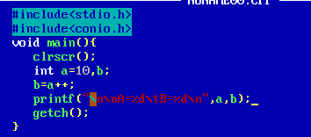
Output:
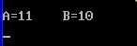
Example of pre increment
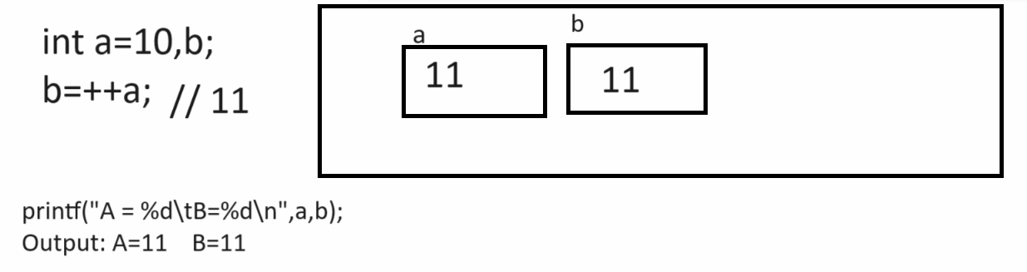
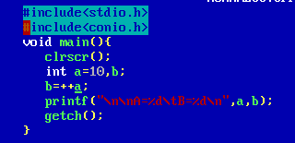
Output:
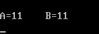
6. Conditional operator: conditional operator is used for check the conditions.
Operator | Meaning
? | Ternary operator
: | Colon operator

If we want to work with conditional operator we have following standard syntax.

Syntax: exp1? exp2: exp3;
exp1 is always condition and exp2 and exp3 are the options if exp1 is true then exp2 get executed if exp1 is false then exp3 get executed.

Example:
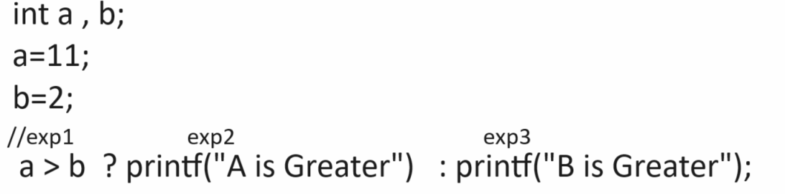

Constant in C Language
___________________________________________________________________________
Q. what is constant?
________________________________________________________________
Constant means value never change in program called as constant

Q. Why use constant or what is benefit of constant?
_______________________________________________________________________
Reusability is major goal of constant

Types of constant in c language
a) Numeric constant
i) Integer constant: that constant store only without decimal point number called as integer constant
Example: 100,200 ,
ii) float constant: float constant is used for store floating values like as
5.4,2.4,etc
iii) octal constant: if we have any value between 0 to 7 preceding 0 called as octal
Example: 072
iv) hexa decimal constant: if we have any value between 0 to 15 and start with 0x
called as hexa decimal
Example: 0x72
b) Character Constant:
i) single character constant: if we use any value between single quote called as single character constant.
Example: ‘a’, ‘5’, ‘z’
ii) string character constant: when we want to store more than one character as constant then we can use string and we can mention the string constant by using “”
Example: “abc”, “mno”,”pqr” etc

7. Bitwise operator.

